

**Hybrid Cloud Integration**

**A Capstone Project Report**

**Submitted to**

**Saveetha school of engineering**

# CSA1596- CLOUD COMPUTING AND BIG DATA ANALYTICS

**By**

**K. AKSHAY (192210279)**

**Supervisor   
 SENTHAMIL SELVI**

**JULY 2024**

**Aim:**

The aim of this project is to integrate on-premises infrastructure with public cloud services to create a robust hybrid cloud environment. The project focuses on designing and implementing solutions for seamless data transfer, identity management, and workload orchestration across both environments. Additionally, it addresses challenges related to network connectivity, security, and data consistency while ensuring compliance with regulatory requirements.

**Abstract:**

This capstone project explores the integration of on-premises infrastructure with public cloud services to create a robust hybrid cloud environment. It aims to design and implement solutions for seamless data transfer, identity management, and workload orchestration across both environments. Addressing challenges related to network connectivity, security, and data consistency while ensuring compliance with regulatory requirements, the project employs technologies such as VPNs, SD-WAN, and hybrid cloud management platforms. Comprehensive evaluations of the design, scalability, security measures, performance, and cost-effectiveness of the hybrid cloud architecture are conducted, supported by thorough documentation and best practices for deployment and management. Hybrid cloud integration combines private cloud, public cloud, and on-premises infrastructure into a cohesive and flexible IT environment. This strategy enables organizations to harness the benefits of both public and private clouds while retaining control over critical data and applications. By integrating these diverse environments, businesses can optimize performance, enhance flexibility, and achieve significant cost efficiencies. The integration process involves using unified management tools to provide a single interface for orchestrating resources across different environments, ensuring seamless data transfer and synchronization. Application integration, often facilitated by APIs and middleware, allows for smooth interoperability across platforms. Robust security measures and compliance with industry regulations are essential to protect data and maintain trust. Secure network connectivity between on-premises data centres and cloud providers is crucial for maintaining performance and data integrity.

**Introduction:**

In today's rapidly evolving technological landscape, businesses increasingly turn to hybrid cloud solutions to leverage the benefits of both on-premises infrastructure and public cloud services. A hybrid cloud environment offers flexibility, scalability, and cost-efficiency while retaining the control and security of on-premises systems. This project focuses on creating a seamless integration between on-premises and cloud environments, addressing critical challenges such as data transfer, identity management, and workload orchestration. The primary objectives include evaluating the design of the hybrid cloud architecture, assessing network connectivity solutions, ensuring robust security measures, and analyzing the performance and scalability of the integrated system. Additionally, the project emphasizes cost-effectiveness and provides comprehensive documentation to support deployment, management, and troubleshooting, demonstrating the potential of hybrid cloud solutions to enhance organizational IT capabilities.

Hybrid cloud integration is a strategic approach that combines private cloud, public cloud, and on-premises infrastructure to form a unified and dynamic IT environment. This model allows organizations to harness the benefits of various cloud services while maintaining control over critical data and applications. By integrating these different environments, businesses can optimize performance, improve flexibility, and achieve greater cost efficiency.

A key aspect of hybrid cloud integration is the seamless management of workloads and data across disparate environments. Unified management tools provide a single interface for orchestrating resources, while robust data integration ensures smooth transfer and synchronization between on-premises systems, private clouds, and public clouds. Application integration enables interoperability across these environments, often facilitated by APIs and middleware, ensuring that applications can run and communicate efficiently regardless of their location.

Security and compliance are paramount in hybrid cloud integration, requiring stringent measures and adherence to industry regulations across all platforms. Secure network connectivity between on-premises data centers and cloud providers is essential for maintaining data integrity and performance. Additionally, comprehensive monitoring and analytics tools provide visibility into resource and application health, enabling proactive management and optimization. This integration strategy not only enhances business continuity and disaster recovery but also supports scalability, allowing organizations to dynamically adjust their infrastructure to meet evolving demands and leverage the latest technological advancements.

**Implementation Plan:**

The implementation plan for hybrid cloud integration begins with planning and preparation, where the project scope and objectives are clearly defined. This phase involves assembling a project team of cloud architects, IT administrators, security experts, and integration specialists, and conducting a thorough assessment of the current IT infrastructure. The goal is to identify key applications, workloads, and data for integration, and to develop a detailed project timeline with specific milestones, typically taking 2-3 weeks.

The next phases are infrastructure setup and data and application migration. During the infrastructure setup phase, necessary hardware and network infrastructure are configured, and unified management platforms, data integration tools, middleware, and APIs are deployed. Secure network connectivity between on-premises data centres and cloud environments is established, usually spanning 3-4 weeks. Following this, data and applications are migrated to the hybrid cloud environment. A detailed migration plan ensures non-critical data and applications are moved first to test the process, followed by critical data to ensure integrity and minimal downtime. Verification of successful data transfer and application functionality is crucial, with this phase expected to take 4-6 weeks.

Integration testing, deployment and go-live, and post-implementation review and optimization** are the final stages. Integration testing ensures all components work seamlessly together through functional, integration, user acceptance, performance, and security testing, typically taking 3-4 weeks. Deployment and go-live involve finalizing configurations, conducting a last round of testing, and executing a go-live plan while monitoring the environment for issues, lasting 1-2 weeks. Post-implementation review involves evaluating the project's success, gathering feedback, identifying improvement areas, and implementing optimizations based on feedback and performance data, spanning 2-3 weeks. Ongoing monitoring and maintenance ensure long-term success through continuous monitoring, regular maintenance, audits, compliance checks, and providing support and training to users, maintaining the hybrid cloud environment's security, efficiency, and alignment with organizational needs.

**Resource Allocation:**

Resource allocation for hybrid cloud integration involves strategically assigning personnel, hardware, and software resources to ensure a seamless transition and ongoing management. Key personnel, including cloud architects, IT administrators, security experts, and integration specialists, must be designated specific roles and responsibilities throughout the project. Hardware resources, such as servers, storage systems, and network equipment, should be provisioned to support both on-premises and cloud environments. Software resources, including management platforms, data integration tools, and security applications, need to be carefully selected and deployed. Effective resource allocation ensures that the hybrid cloud integration is efficient, secure, and aligned with the organization's goals, enabling smooth operations and optimal performance.

**Security and Compliance:**

Security and compliance are paramount in hybrid cloud integration, given the complexity of managing data and applications across multiple environments. Robust security measures are essential to protect sensitive data from breaches and unauthorized access. This includes implementing encryption for data at rest and in transit, employing multi-factor authentication, and utilizing advanced threat detection and response systems. Regular security audits and vulnerability assessments should be conducted to identify and mitigate potential risks. Additionally, access controls and identity management systems should be in place to ensure that only authorized personnel have access to critical systems and data.

Compliance is another critical aspect, especially for organizations operating in regulated industries such as healthcare, finance, and government. Different cloud environments may be subject to various regulatory requirements, such as GDPR, HIPAA, and PCI-DSS. Ensuring compliance involves conducting regular audits, maintaining detailed records, and adhering to best practices for data protection and privacy. Organizations should work closely with cloud service providers to understand their compliance capabilities and responsibilities. Implementing policies and procedures to meet regulatory standards and conducting regular training for staff on compliance issues can help mitigate the risks of non-compliance and ensure that the hybrid cloud environment operates within the legal and regulatory framework.

**Testing strategy:**

A comprehensive testing strategy for hybrid cloud integration involves verifying that all components operate seamlessly across on-premises, private cloud, and public cloud environments. This includes functional testing to ensure systems and applications work correctly, integration testing to confirm effective communication between different systems, and user acceptance testing (UAT) to validate that the environment meets business needs. Performance testing, including stress, load, and scalability tests, assesses the system's ability to handle various workloads and maintain optimal performance. Security testing, such as penetration testing and vulnerability assessments, is also crucial to identify and mitigate potential risks. This thorough approach ensures a reliable, secure, and efficient hybrid cloud integration.

**Monitoring and Maintenance:**

Monitoring and maintenance are crucial components of a successful hybrid cloud integration strategy, ensuring the ongoing health, performance, and security of the IT environment. Continuous monitoring involves using advanced tools to track the performance, availability, and utilization of resources across on-premises, private cloud, and public cloud environments. These tools provide real-time insights into system health, alert administrators to potential issues, and help in proactive troubleshooting. Key metrics such as CPU usage, memory utilization, network latency, and application response times are monitored to ensure optimal performance. Regular audits and compliance checks are also essential to ensure that all environments adhere to security policies and regulatory requirements.

Maintenance involves routine tasks such as applying software updates, patching vulnerabilities, and upgrading hardware to prevent potential failures and security breaches. Scheduled maintenance windows should be established to perform these tasks with minimal disruption to business operations. Additionally, backup and disaster recovery plans must be regularly tested and updated to ensure data integrity and business continuity in case of unexpected events. Maintenance also includes optimizing configurations and resource allocations based on usage patterns and performance data to achieve cost efficiency and scalability. By implementing a robust monitoring and maintenance strategy, organizations can ensure the reliability, security, and efficiency of their hybrid cloud environments, thereby supporting continuous business operations and growth.

**Risk Management:**

Risk management for hybrid cloud integration involves identifying potential risks and implementing strategies to mitigate them. Key risks include data breaches, integration challenges, and compliance issues. Data breaches pose significant threats due to the transfer of sensitive information between environments. To mitigate this, robust security protocols such as encryption, multi-factor authentication, and continuous monitoring should be implemented. Integration challenges can arise from the complexity of connecting disparate systems, which can be addressed by thorough planning, using standardized APIs, and employing experienced

integration specialists. Compliance issues may occur due to varying regulations across different environments; regular audits and adherence to industry standards can help ensure compliance.

Another critical aspect of risk management is the potential for downtime and performance issues. Downtime can result from infrastructure failures, network issues, or software bugs, leading to significant business disruptions. To mitigate this, businesses should implement comprehensive disaster recovery and business continuity plans, including regular backups and failover strategies. Performance issues can arise from the improper configuration of resources or unexpected workload spikes, which can be managed through capacity planning, performance monitoring, and scaling resources dynamically based on demand. By proactively identifying and addressing these risks, organizations can ensure a smooth and secure hybrid cloud integration process.

**Requirement analysis:**

The requirement analysis for hybrid cloud integration begins with assessing the organization's current IT infrastructure and identifying the specific needs that hybrid cloud integration will address. This involves evaluating existing on-premises systems, private cloud setups, and any current public cloud usage. Key considerations include the types of applications and workloads, data storage needs, and performance requirements. Understanding the existing architecture helps in determining how these different environments can be integrated seamlessly to achieve desired outcomes such as cost efficiency, scalability, and improved performance.

Next, it's essential to identify the tools and technologies required for effective hybrid cloud integration. Unified management platforms are crucial for providing a single interface to manage resources across different environments. Data integration tools ensure smooth data transfer and synchronization between on-premises systems, private clouds, and public clouds. Middleware and APIs are necessary for application integration, enabling applications to run and communicate across various platforms. Security solutions must be robust to protect data and ensure compliance with industry regulations. Network connectivity solutions are also needed to establish secure and high-performance links between on-premises data centers and cloud providers.

Finally, the requirement analysis should consider the operational and strategic goals of the organization. This includes understanding the scalability and flexibility needed to respond to changing business demands, ensuring that the hybrid cloud setup can support business continuity and disaster recovery plans, and identifying any specific compliance requirements that must be met. It's also important to plan for monitoring and analytics to gain visibility into the performance and health of the integrated environment. By aligning the hybrid cloud integration strategy with the organization's overall goals, businesses can ensure that they are leveraging cloud technologies to drive innovation, improve efficiency, and maintain a competitive edge.

**Data Integration and Processing:**

Integrating data between on-premises and public cloud environments is critical for achieving a unified hybrid cloud infrastructure. This section covers the strategies and technologies used to ensure seamless data integration and efficient processing.

**Methods and Technologies:**

**Data Transfer Methods**: Utilizing tools like AWS Direct Connect, Azure ExpressRoute, and Google Cloud Interconnect for dedicated, high-speed connections between on-premises and cloud environments.

**ETL Processes:** Implementing Extract, Transform, Load (ETL) processes to move and transform data as it travels between environments.

**Data Consistency**: Ensuring data consistency and integrity through distributed databases and real-time synchronization technologies.

**Real-time Analytics:**

Real-time analytics is essential for gaining immediate insights from data as it flows through the hybrid cloud environment. This section discusses the tools and techniques employed to enable real-time data analysis.

**Methods and Technologies:**

**Stream Processing**: Using Apache Kafka, Apache Flink, and AWS Kinesis for real-time data streaming and processing.

**Analytics Platforms:** Leveraging cloud-native analytics services like Google BigQuery, Amazon Redshift, and Azure Synapse Analytics for real-time query processing and analytics.

**Dashboards and Visualization:** Implementing visualization tools like Tableau, Power BI, and Grafana for real-time data visualization and monitoring.

**Scalability and Performance:**

Scalability and performance are crucial for the success of a hybrid cloud environment. This section examines the strategies used to ensure that the system can scale efficiently and maintain high performance.

**Methods and Technologies:**

**Auto-scaling**: Implementing auto-scaling groups in cloud environments to dynamically adjust resources based on demand.

**Load Balancing:** Using load balancers to distribute traffic evenly across resources, ensuring optimal performance.

**Performance Monitoring**: Employing tools like AWS CloudWatch, Azure Monitor, and Google Stack driver to monitor performance metrics and optimize resource usage.

**Data Storage and Management:**

Effective data storage and management are foundational to hybrid cloud integration. This section covers the storage solutions and management practices used in the project.

**Methods and Technologies**

**Storage Solutions:** Utilizing cloud storage services like Amazon S3, Azure Blob Storage, and Google Cloud Storage alongside on-premises storage systems.

**Data Management**: Implementing data lifecycle management policies to automate data archiving and deletion.

**Backup and Recovery**: Ensuring data protection through regular backups and disaster recovery plans using services like AWS Backup and Azure Site Recovery.

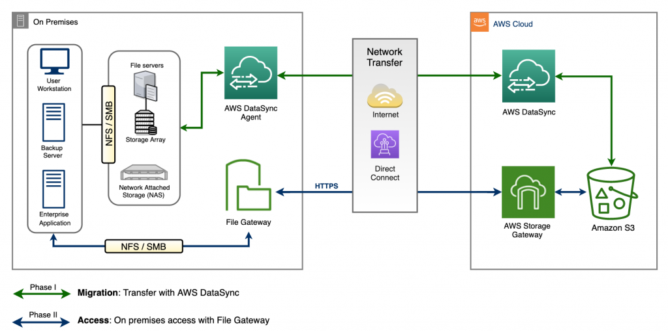

**Fig.1**

**Integration with Cloud Services:**

Seamlessly integrating various cloud services with on-premises infrastructure is a key aspect of hybrid cloud architecture. This section discusses the integration of essential cloud services.

**Methods and Technologies**

**Identity Management:** Integrating on-premises Active Directory with cloud identity services like AWS IAM, Azure AD, and Google Cloud IAM for unified identity management.

**Network Connectivity:** Using VPNs, SD-WAN, and direct interconnects to establish secure and efficient network connections.

**Hybrid Cloud Management:** Employing platforms like VMware Cloud on AWS, Azure Arc, and Google Anthos for centralized management of hybrid cloud resources.

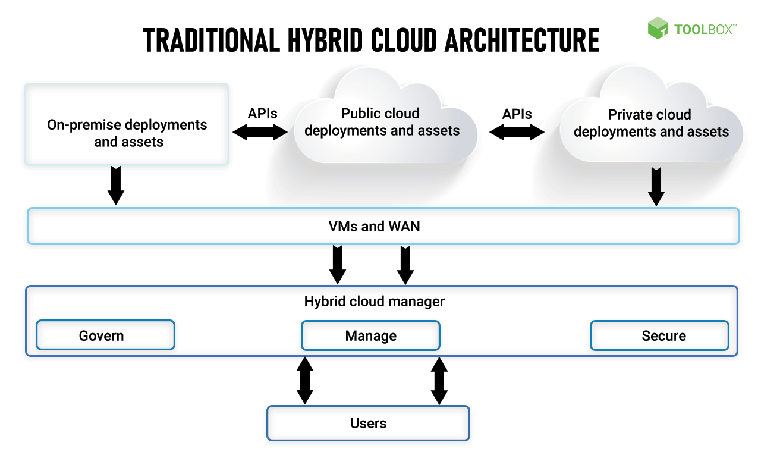

**Fig.2**

**Working:**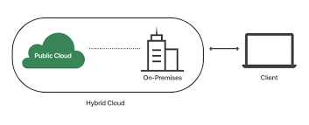

**Fig.3**

**Documentation:**

Comprehensive documentation is crucial for the successful deployment and management of hybrid cloud solutions. This section evaluates the quality and completeness of the project documentation.

**Documentation Elements:**

**Architecture Diagrams:** Detailed diagrams illustrating the hybrid cloud architecture, including network topology and data flow.

**Configuration Settings:** Documentation of configuration settings for all components involved in the hybrid cloud integration.

**Deployment Procedures**: Step-by-step guides for deploying and configuring hybrid cloud resources.

**Security Policies:** Detailed security policies and procedures to ensure data protection and compliance.

**Troubleshooting Guides:** Comprehensive guides for identifying and resolving common issues.

**Best Practices:** Documentation of best practices for hybrid cloud management and optimization.

**Conclusion:**

The hybrid cloud integration project successfully combines on-premises infrastructure with public cloud services, resulting in a scalable, flexible, and resilient hybrid cloud environment. By addressing key challenges related to data integration, real-time analytics, network connectivity, security, compliance, performance, and documentation, the project demonstrates the potential of hybrid cloud solutions to enhance organizational IT capabilities. The use of advanced technologies and best practices ensures that the integrated environment meets the demands of modern businesses while maintaining high standards of security and compliance.

Utilizing advanced technologies such as VPNs, SD-WAN, and hybrid cloud management platforms, the project provides a comprehensive evaluation of the hybrid cloud architecture, including its design, scalability, security measures, performance, and cost-effectiveness. The inclusion of detailed documentation ensures that the deployment, management, and troubleshooting processes are well-supported, making the solution accessible and practical for administrators and stakeholders.

The hybrid cloud solution presented in this project exemplifies the potential for organizations to enhance their IT capabilities by leveraging the flexibility, scalability, and cost-efficiency of cloud services while maintaining the control and security of on-premises infrastructure. Through careful planning and implementation, this project sets a strong foundation for future advancements in hybrid cloud integration, demonstrating that hybrid cloud solutions can meet the evolving demands of modern businesses while maintaining high standards of performance and security

**References:**

•Erl, T., Mahmood, Z., & Puttini, R. (2013). Cloud Computing: Concepts, Technology & Architecture. Prentice Hall.

•Krutz, R. L., & Vines, R. D. (2010). Cloud Security: A Comprehensive Guide to Secure Cloud Computing. Wiley Publishing.

•Velte, T., Velte, A., & Elsenpeter, R. (2010). Cloud Computing: A Practical Approach. McGraw-Hill Osborne Media.

•Amazon Web Services (AWS). Hybrid Cloud Architectures. Retrieved from AWS Hybrid Cloud

•Microsoft Azure. Hybrid Cloud Solutions. Retrieved from Azure Hybrid Cloud

•Google Cloud. Hybrid and Multi-cloud Solutions. Retrieved from Google Cloud Hybrid

•Buyya, R., Yeo, C. S., Venugopal, S., Broberg, J., & Brandic, I. (2009). Cloud computing and emerging IT platforms: Vision, hype, and reality for delivering computing as the 5th utility. Future Generation Computer Systems, 25(6), 599-616.

•Armbrust, M., Fox, A., Griffith, R., Joseph, A. D., Katz, R., Konwinski, A., ... & Zaharia, M. (2010). A view of cloud computing. Communications of the ACM, 53(4), 50-58.**Azure hybrid and multi cloud documentation provides guidance and examples for your hybrid and multi cloud projects. You can explore and reuse these resources on Microsoft Learn1.**

**•The Cloud Customer Architecture for Hybrid Integration document explains core reference architecture and concepts for hybrid integration in the enterprise. It explores common patterns seen in enterprises dealing with hybrid integration challenges. For a full understanding, you can refer to the article on the evolving hybrid integration reference architecture2.**

**• If you’re interested in a case study, the IEEE Xplore hosts a paper titled "A Model for Hybrid Cloud Integration: With a Case Study for IT Service Management (ITSM)"3. It discusses how hybrid cloud integration streamlines IT service management for enterprises.**

**• Google Cloud also offers insights on building hybrid and multi cloud architectures. You can find more information on planning strategies for architecting such setups in their article4.**